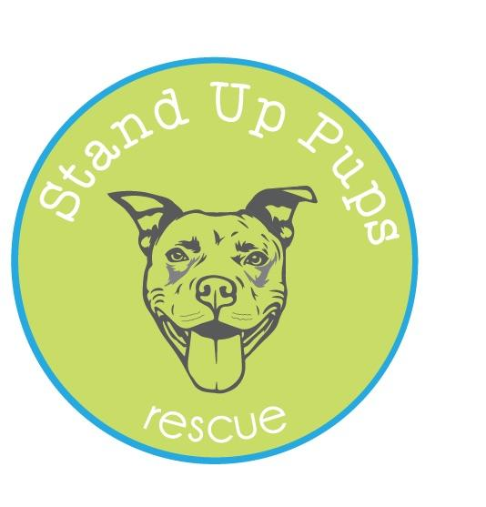
Stand Up Pups, a Georgia licensed, 501c3 rescue

Foster Home Agreement

I, being the responsible spokesperson for my household:

1. Agree to foster animals until adopted into an acceptable home. Fostering
responsibilities include providing fresh water, food, and shelter.

2. Agree that my foster pets will be kept in temperature-controlled environments

3. Agree there will be a smoke/fire detector and a fire extinguisher on each level where foster animals are housed.

4. Attest that no one in my household has ever been charged or convicted of any state or local animal cruelty or neglect violations.

5. Will provide transportation to and from adoptions and veterinary visits. Should I be unable to provide such transportation, I will notify Stand Up Pups as soon as possible so that alternative arrangements can be made.

6. Agree that no foster dog shall be tied up with rope, chained, put on a run or confined in an inadequate pen facility.

8. Agree that if I decide I want to adopt the animal, I will talk with Stand Up Pups immediately

9. Agree that all primary enclosures where animals are housed will be kept cleaned and free of feces and other contaminated matter.

10. Agree that both personal and foster animals exhibiting a vicious disposition must be housed individually. Animals suspected of having a communicable or infectious disease must be separated from other animals.

11. Agree that I will report to Stand Up Pups immediately should my foster pet exhibit any aggressive behavior, and especially a dog bite incident.

12. Agree that I will contact Stand Up Pups when any animal shows signs of illness.

13. Agree that I will follow the medical protocols provided by Stand Up Pups, including routine testing, spay/neutering, vaccinations, microchipping, and parasite control for all foster animals.

14. Agree that all dogs over the age of 12 weeks will wear their Stand Up Pups collar and Name Tag

15. Agree that I am responsible to abide by the State Law and have my foster animal(s) on a leash at all times outside of the home / anytime in public.

16. Agree that I am responsible for purchasing food and other basic supplies for my foster animal(s), except for donated food that may be provided by Stand Up Pups

17. Agree that I will support the effort to find suitable homes for my animals, including:

- Transporting my foster dogs to adoption events, except for those cases (such as young puppies, dogs with behavioral problems, and ill dogs) that would preclude the animals from appearing at public events.
- Providing photos and descriptions of your foster dog to Stand Up Pups to promote online

18. Agree that I will keep a copy of all foster paperwork available for inspection by the
Georgia Department of Agriculture.

Name: ____________________________
Address: _________________________________________________________
City: ________________________ State: ____________ Zip: _______________
Home Phone: ___________________ Mobile Phone: _____________________
Email: ____________________________

I have read the above information carefully and have filled out this application honestly. I understand that at all times a pet is in foster care that the pet is the property of Stand Up Pups Any misinformation or omission of information and/or failure to answer all questions and sign the application can result in this application being declined. Also, if an omission or untruth is discovered after a dog is placed in foster, I understand that Stand Up Pups reserves the right to annul the foster and immediately reclaim the animal. I give Stand Up Pups permission to fully investigate the information provided as well as contact veterinarians and related officials.

Name of dog: _______________________

Foster Signature: ___________________________________ Date: _______________

Please email to Becca Fischer-Tripodi (standuppups@gmail.com)

CEO of Stand Up Pups Signature: _____________________ Date: ________________

Foster home is approved to foster: ___dogs ___puppies

